Christopher Guay

EDSGN 420

HW3: Hough Transforms

Objective:

To explore the concept of a Hough Transformation in MatLab by detecting a circle’s presence and recording it’s center and radius.

Code:

The code was done in three iteration: a single circle, unobscured, an obscured circle, and multiple. The code is in that same order.

Test 1:

im = imread('C:\Users\Christopher Guay\Documents\school\PSU Spring 2020\EDSGN 420\Computer vision\IM3_1.jpeg');

imshow(im);

Rmin = 120; Rmax = 300; % need to supply estimate of radius (in pixels)!

[center, radius] = imfindcircles(im, [Rmin Rmax], 'Sensitivity', 0.9);

viscircles(center, radius);

hold on; plot(center(:,1), center(:,2), 'yx', 'LineWidth', 2);

hold off;

Test 2:

im = imread('C:\Users\Christopher Guay\Documents\school\PSU Spring 2020\EDSGN 420\Computer vision\IM3_3.jpg');

imshow(im);

Rmin = 20; Rmax = 110; % need to supply estimate of radius (in pixels)!

[center, radius] = imfindcircles(im, [Rmin Rmax], 'Sensitivity', 0.93);

viscircles(center, radius);

hold on; plot(center(:,1), center(:,2), 'yx', 'LineWidth', 2);

hold off;

Test 3:

im = imread('C:\Users\Christopher Guay\Documents\school\PSU Spring 2020\EDSGN 420\Computer vision\IM3_3.jpg');

imshow(im);

Rmin = 20; Rmax = 110; % need to supply estimate of radius (in pixels)!

[center, radius] = imfindcircles(im, [Rmin Rmax], 'Sensitivity', 0.93);

viscircles(center, radius);

hold on; plot(center(:,1), center(:,2), 'yx', 'LineWidth', 2);

hold off;

Results:

Test 1:

Input:

 (619x598)

Radius, Center = 302.2031, 364.6755

Output:

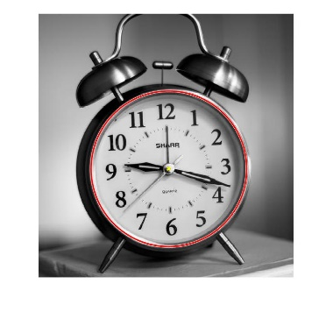

Test 2:

Input:

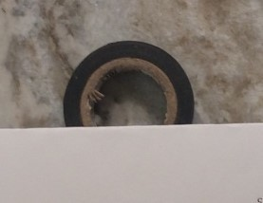 (214x277)

Radius, Center = 137.4616, 110.7612

Output:

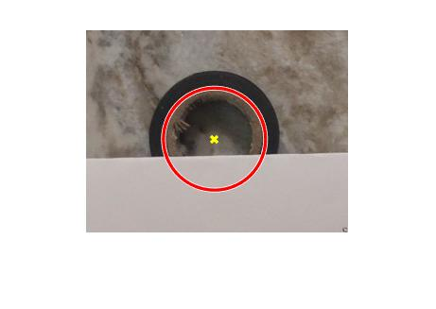

Test 3:

Input:

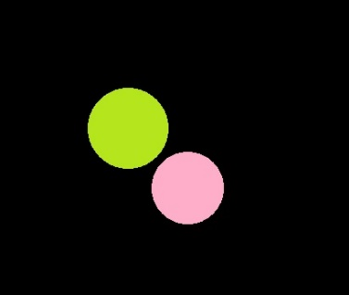 346x410

Radius, Center = 220.9264, 221.0903; 150.4008, 151.0216

Output:

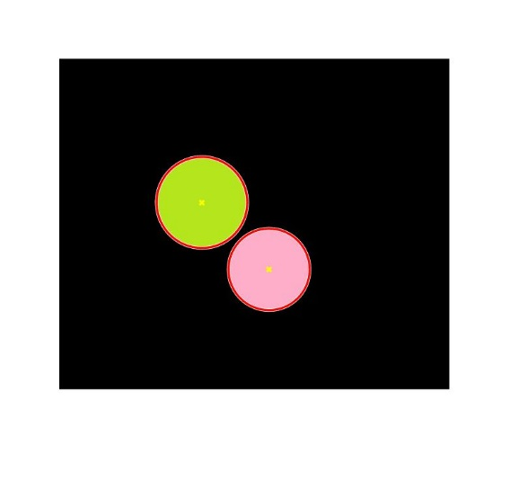

Conclusion:

Getting MatLab’s imfindcircles function was difficult, and the only way I was able to make it work on a consistent basis was by the alteration of the default sensitivity parameter of 0.85. This parameter directly effects how sensitive the function is to picking up what MatLab thinks is a circle. Going too high with the sensitivity trivializes the function as it picks up everything and ceases to perform any sort of useful operation. The function works best when there is a darker background than the circle, as can be seen in all tests. Whenever there is a dark circle bordering the outside of a lighter, inner circle, matlab misses the outer circle and only sees the inner one.